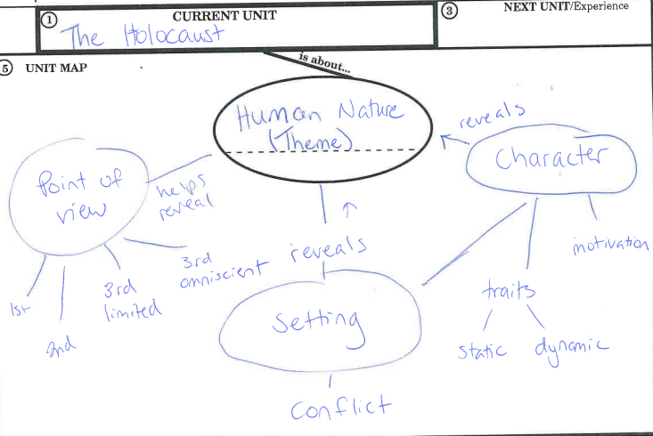
Essential Questions | Targets
- How does a setting affect the mood, conflict, or characters in a story?  - What motivates some characters to be compassionate and what motivates others to be cruel?  - Why does an author choose to write from a certain point of view? How does the point of view help to reveal the author’s message?  - What are different texts and authors suggesting about human nature? | - I can describe how the setting affects the mood, conflict, or characters in a story.  - I can explain what motivates some characters to be compassionate and others to be cruel. I can cite evidence to support my explanation.  - I can analyze why an author might choose to write from a certain point of view and explain how that point of view helps reveal the author’s message.  - I can interpret a text’s message about human nature and cite evidence to support my interpretation.

Literary Terms
- Static--lacking movement or change. Static characters’ traits don’t change throughout a story.
- Dynamic--Constantly changing, moving, or progressing. Dynamic characters’ traits change throughout a story.
- Motivation--Why someone does something, the force that drives people to behave or act in a certain way.
- Theme--The author’s message about life, people, human nature, the world, etc.
- Biased--favoring or preferring one side, opinion, issue, group, or person over another; not fairly representing both sides of an issue.
- Unbiased--Not favoring or preferring one side, opinion, issue, group, or person over another; fairly representing both sides of an issue.

- __________________________________--who is telling the story; the vantage point, perspective.

- __________________________________--This is when the narrator is a character in the story. This point of view uses “I.”

- __________________________________--This is when the author writes as if you are the main character in the story.
- __________________________________--This is when the narrator is not a character in the story but knows everything and can tell you about any characters’ thoughts and feelings. (Think of the narrator as a fly on the wall that can go anywhere and follow anyone.)

- __________________________________--This is when the narrator is not a character in the story but focuses on the thoughts and feelings of a single character. (Think of the narrator as a fly that follows around a single character.)

Check your understanding! Read the following passages and decide which point of view each one is written from.

Bob was walking to school one day when all of sudden he heard a buzzing noise and felt a wind blow the hair off his face. He looked up to see a flying saucer! His heart started to race, and he wondered if he should run or stay and watch. Suddenly a beam of green light struck him, and he felt himself begin to float upwards. He realized he was being abducted by aliens.

This is _______________________________________________________________ point of view.

As the aliens flew over Earth in their spaceship, they saw a strange creature walking. It was bipedal and mostly hairless, except for a patch on the top of its head--rather ugly they thought. They wondered if it was one of those “Earthlings” they had come to learn about. They decided this would make a wonderful addition to the collection of specimens they had already gathered. They could put it in with the barking quadrupeds and see if one creature would devour the other.

This is _______________________________________________________________ point of view.
Bob was walking to school one day when all of sudden he heard a buzzing noise and felt a wind blow the hair off his face. He looked up to see a flying saucer! His heart started to race, and he wondered if he should run or stay and watch.
The aliens in the spaceship saw the boy walking and thought to themselves that the bipedal creature was rather ugly; it was mostly hairless except for a patch on the top of its head. They wondered if it was one of those “Earthlings” they had come to learn about. They decided this would make a wonderful addition to the collection of specimens they had already gathered. They could put the boy in with the dogs they had abducted earlier and see if one creature would devour the other.
They pushed a few buttons and a beam of green light struck Bob. He felt himself begin to float upwards and realized he was being abducted by aliens.

This is _______________________________________________________________ point of view.

You are walking to school one day when all of sudden you hear a buzzing noise and feel a wind blow the hair off your face. You look up to see a flying saucer! Your heart starts to race, and you wonder if you should run or stay and watch. Suddenly a beam of green light strikes you, and you feel yourself begin to float upwards. You realize you are being abducted by aliens.

This is _______________________________________________________________ point of view.

I was walking to school one day when all of a sudden I heard a buzzing noise and felt a wind blow the hair off my face. I looked up to see a flying saucer! My heart started to race, and I wondered if I should run or stay and watch. Suddenly a beam of green light struck me, and I felt myself begin to float upwards. I realized I was being abducted by aliens.

This is _______________________________________________________________ point of view.

